Phase B: Preliminary Design and Technology Completion

Brandon Hickey

9/23/2023

Following: <https://www.eng.auburn.edu/~dbeale/ESMDCourse/Chapter2.htm>

# Purpose

To define the project in enough detail at all levels (system, subsystem and components) to establish a Preliminary Design that has no unresolved design or technology issues. Per [2], a Preliminary Design “meets all the system requirements with acceptable risk and within cost and schedule constraints and establishes the basis for proceeding with detailed design. It will show that the correct design option has been selected, interfaces have been identified, and verification methods have been established.”

# Trade-Studies

## Option #3 Trainer style, High-Wing, Single Engine

This is a basic model used for many beginners in remote-controlled fixed-wing aircraft. The high-wing design and potential dihedral provides more stability in flight and would have the motor mounted to the nose, providing thrust in line with the center of mass and low wiring complexity to connect motor to control. It does have the issue of needing to angle the motor (Thrust angle) to counter aircraft tendencies. With a single engine we will need to be more cautious of our weight and payload constraint, however the ease of designing and manufacturing with less required strength on the wings than a multi-engine frame would offset this.

## Trade Study Result

|  |  |  |  |  |  |
| --- | --- | --- | --- | --- | --- |
| Criteria | Weight | Twin Boom 1E | Twin Boom 2E | Trainer 1E | Trainer 2E |
| Score | Score | Score | Score |
| Expected Ease of Designing | 15 | 6 | 3 | 12 | 9 |
| Expected Ease of Manufacturing | 10 | 6 | 4 | 8 | 6 |
| Expected Ease of assembling | 15 | 6 | 3 | 9 | 6 |
| Durability/Rigidity | 10 | 8 | 6 | 8 | 6 |
| Maneuverability | 10 | 8 | 10 | 6 | 6 |
| Aesthetic/Personal Taste | 5 | 3 | 4 | 2 | 4 |
| Stability | 15 | 9 | 9 | 12 | 12 |
| Weight w/o Payload | 10 | 8 | 6 | 8 | 6 |
| Payload Capacity | 10 | 4 | 6 | 4 | 6 |
| Total | 100 | 58 | 51 | 69 | 61 |

Based on an overview of the frame type, we can conclude that for at least a first full attempt, the trainer is the most viable option for success. While it does not contain as much potential thrust as the multi-engine frames, its ease of design, manufacturing, and assembly, along with natural stability, makes it a clear choice. Moving forward, we will perform our reviews and development with the Single-Engine High-Wing Trainer.

# Plane Design Specifications

This will be based on a design generator from <https://rcplanes.online/design.htm> that will be used to feed in some design parameters to develop a trade study for several given wingspans and wing chords.

## Reynolds Number

I will be working with a Reynolds number, Re, to aid in understanding the relationship with the airflow as well as for selecting an airfoil type that will be used within the plane design to determine my flight performance.

Reynolds number is given by:

Re = (air density / air viscosity) * air speed * wing chord.   
  
Of these we have some standard values for Air Viscosity and Air Density, followed by our inputs of air speed and wing chord. We have a rough goal in mind of our target airspeed given in the SE Function #1 of 9 – 13.5 m/s cruising speed. We will then combine this Re with the trade study of wingspans and wing chords to determine performance between options.

## Trade Study

Using the generator, we have 5 inputs per design. While these may all result in different sizes and weights, we are going to assume that our final design for each version will be at the max weight of 1,000 grams.

## Lift Study

We have 4 main sets of data to look at based on two variables: Cruising Speed, and Aspect Ratio. For all sets, we used a wingspan range from 250 mm to 1500 mm. From there we have the high and low end of our desired cruising speed as the two points (9m/s and 13.5 m/s). Lastly, we have the aspect ratio of the aircraft.

With each set we calculate the attached Reynolds Number that is based on the outputs of the generator and our input variables. To simplify things in terms of available Airfoil models, we are using a S7055 flat-bottomed airfoil model with three potential Reynolds Number Versions: 50,000, 100,000, and 200,00. The range of each is based on which is closer to the other. Anything with a Re lower than 75,000 will use the 50,000 version. Anything between 75,000 and 150,000 will use the 100,000 version. And all of the above will use the 200,000 version.

The results of each will then look at the lift generated at 3 angles of attack (AoA): 0, 5, and 10 degrees. We will then identify on the plot whether a given generated set not only can handle the max 1 kg aircraft weight, but also handles the additional 300g payload. From this test, we will determine the most likely to succeed candidates, then perform another round of testing with more defined Wingspan and Cruising speed values after removing all unlikely candidates.



From the results, we can make several assumptions.

1. Our cruising speed must be higher than 9 m/s. At no testing set did we maintain a greater lift than the weight of our vehicle for any available wingspan, speed, and aspect ratio. However, we did succeed in both aspect ratios in providing enough lift at the high end of our cruising speed.
2. We must reduce our maximum possible wingspan: From the generator results, we notice that at our highest aspect ratio of 6:1, our average chord length at a wingspan of 1500 mm was 250mm, greater than our desired maximum build size. We also noted that 1250 mm was too large. Based on this, we can decide that for an aspect Ratio of 6, we can not have a larger wingspan than 1200mm and for an aspect ratio of 5 we can not have a larger wingspan than 1000mm. This, however, does not provide any successful datasets. So, we will perform our test again, with the following constraints and changes.
   1. Wingspan at AR 6: 1200 mm
   2. Wingspan at AR 5: 1000 mm
   3. Max cruising Speed: 15 m/s

This provides the following new results:



We now have an additional set of possible configurations that satisfy both of our constraints. If we remove the options that have too large of build size, we are left with the following options:

1. Aspect Ratio 5, Wingspan 1000 mm, Cruising Speed 17 m/s
2. Aspect Ratio 6, Wingspan 1200 mm, Cruising Speed 15 m/s
3. Aspect Ratio 6, Wingspan 1200 mm, Cruising Speed 17 m/s

From here, we must decide what we value more. Both vehicles will have the same average chord length, the 1200 mm wingspan vehicles will have not only the additional 200 mm of material to manufacture for the wings, but an additional 150 mm in fuselage length. While this can provide more room, it will create more weight for the overall vehicle. This may cause us to run against our max weight constraint more often than with the 1000 mm wingspan. Therefore, we will move forward with option #1: Aspect Ratio 5, Wingspan 1000 mm, Cruising Speed 17 m/s.

## Drag Study

Next, let’s take a look at the drag this will produce. We have yet to decide on a motor/propellor set, but we should be able to develop a reasonable expectation for desired thrust based on the weight of our vehicle and drag.

I believe my main focus will be focusing on the drag during cruising conditions, so I will look at the same AoA.

**This study is currently missing drag due to everything else but the wings. Needs work\*\*\***

Looking at the results, The Drag at each AoA is as follows: 0.276 @ 0 deg, 0.334 @ 5 deg, and 0.594 @ 10 deg.

Based on this drag, we can estimate using a free-body diagram to determine the required thrust needed to maintain a speed of 17 m/s.

At 0 degrees angle of attack, we are looking at just the drag of the aircraft versus the thrust of the engine. Meaning us to stay at the same velocity we must produce at least 0.276 newtons of thrust, or **28 grams of thrust? This seems off, but I must also consider that I am not including drag from any other component in this calculation.**

**I believe my next step will be to attempt either a simple python, matlab, or excel script to calculate the thrust required to accelerate from standstill to take-off.**

**Assumptions of the simulation:**

1. Maximum weight and payload
2. Assume plane stays at an AoA of zero degrees
3. Assume the plane leaves the ground and remove friction from the wheels at this point
4. Runway length of 50/100/200/500 feet
5. AoA while on ground of 0/5/10 degrees

## Take-off Study

Looking at the results of our model, we note that leave the ground at roughly 1.91 seconds, clearing 1 meter from the ground at 2.76 seconds. Look at our x-position, we can determine how long of a runway we needed to take-off which is equal to roughly 17.6 meters or 57.75 feet. Our speed at take-off is equal to 15.64 meters per second, close to our excel calculations regarding minimum speed to produce lift equal to our weight and max payload. The local RC field has a runway of 200 feet, meaning it will be satisfactory location and distance for this vehicle.  
  
What we also looked at was the RPM required to maintain this speed of roughly 15.75 meters per second. Due to dynamic thrust as we increase in speed, the returns on our thrust are diminished. So we wanted to find the RPM that would maintain this airspeed.

We find that the break-even RPM to maintain this airspeed is equal to 13,194 RPM. This is around half of our motor speed given a 2200kv motor rated for 3S and a 7 inch diameter propellor with a 3 inch pitch.

We can see our max airspeed should be in the range of 35.2 m/s.

## Overall

This should mean our aircraft design should be capable of taking off of a reasonable runway, and maintaining a cruising speed at roughly 50% power with a max speed of 35.2 m/s

# Trainer Design Specifications

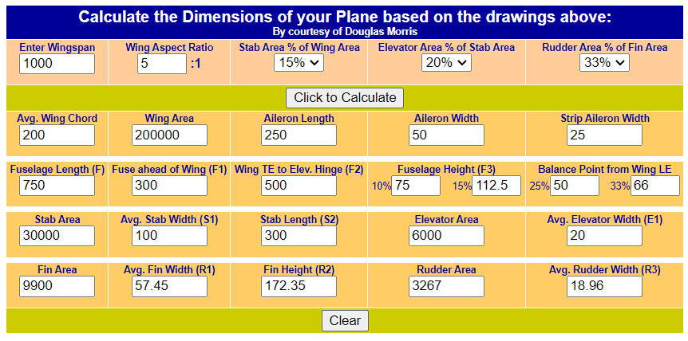

## Wing Loading

Based on an average chord of 200mm and 1000mm wingspan with the maximum weight of 1300 grams, our wing loading is roughly 65 g/sq.dm. This is in a good range for our aircraft and means that any weight we save will make this value decrease, marking this as our max wing load value.

# Plane Design in Fusion360

## Wing Design

So to start I am going to work on building wing of my aircraft. During previous attempts, an it was always an issue on securing ribs together in a way that makes assembling an entire 1 meter wing easy with the inclusion of electronic components and control surfaces. The main issue is the implementation of spars to maintain the correct spaces for ribs, but then needing to add an additional carbon fiber rod to secure wing sections and provide connecting left- and right-wing sections to a central piece.

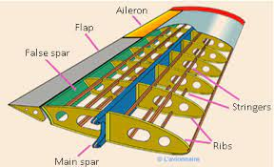

I think my first goal will be to create 5 sections: 2 Left/Right wing pieces, and 1 center merger piece. I think for a first try, I am going to aim to use a single carbon fiber rod that extends halfway for each wing, this will support the bending caused by lift. I think then I will add a second carbon fiber rod slightly offset from the first, or in the same line but with some sort of merging piece to secure the two together. However, it will need to be long and rigid enough to ensure that the bending does not break the joint, causing the wings to flap. To combat this, I will also look to include a main spar running near the rod supporting the top and bottom of the ribs. I am think that to make everything fit into slots, the spars will either interlock somehow between sections, perhaps with a simple friction fit, or I will off-set them along the wing so that each rib will have two spars.

Startign with a S7055 airfoil, we are going to first ensure that we have enough space to fit our SG90 servo. The dimensions we will need to fit will be roughly 12x32mm, with a slot meant to fit a 12x23mm block. While we will focus on servo later, this will provide us the correct placement for our spars and rods to avoid conflict.

We will want to

We want to make sure that the servo does not extend past the top of the rib, and we want a bit of space on the bottom to help encase the servo. To secure the servo casing to the rib we will use the same slot style planned for spars.

I am actually curious if I do alternating spars, if that would be enough for the outerwings, leaving just 2 carbon rods to merge wings and attach to merger.

The goal here is that by alternating the pieces, they should all be connected, which should allow me to string 100mm pieces or so back and forth, So next I am going to cut these spars into alternating pieces.

Instead what I have decided to try is to alternate the up and downs on both front and rear. My worry is that if you twisted in one direction about the center of the rib, it would unlatch itself. While this shouldn’t be a problem with the skin on, I still wanted to stop that.

So instead, we have alternating pieces, plus I added some lightening holes to trim weight, plus it will be good for running wires.

I am currently test printing the batches of spars at my home printer. I will see what the results are of that, I also thankfully labeled all the spars, as otherwise I am going to get lost on what part goes where.

It should not be much added weight, and even if it was, I can cut off the label once the wing is assembled.

Before I move on the from the wing, I will likely print out an entire set, to test the strength and whether I will need to at least maybe put a rod or two through the center.  
  
I also will need to add a rod or something to rotate about for the ailerons.

Added in the ailerons, not sure how I feel about it as the weight is looking like ~35 grams, we will see how it does printed, checking in Cura now says at 10% infill it is saying closer to 22 grams with since the fusion model assumes 100% infill. That’s good at least. I also added in the carbon fiber rods, roughly 300mm roughly 1 foot, which is good as the rods I have in stock are roughly 16 inches. I added in a slot for the control horn as well, I will next need to go about making a secure mount for the SG90 servos.

I believe my plan for the servo mount will be to make some sort of hook similar to the spars and attach it to either the ribs or spars around the center point of the aileron. In previous versions, I had used carbon rods to mount the servo, followed by a plate I had to glue in to the base to make it work.

Update: 9/29/2023

So far, printed most of the wing and I will need to make the following revisions.

Make the spaces between the spars larger. Right now its either a 2mm or 3mm space, which makes a space that can bend easily and break faster. While I don't think its going to be a major issue since the spares should keep it from bending around that point, likely a failure point nonetheless.

It might be lower weight to use only half the spars and use a carbon fiber rod. The issue with the rods is that I need to use atleast 3 rods give they are about 14-16 inches long and the wingspan is 40 inches. This means I need to either bond rods together in a way that wont become a point of breakage, or use twice the rods in an alternating fashion like I am doing with the spars. I will check the weight of the wing after I have completed all the spars and compare that with a few options: 4 spars & no rods, 2 spars and 1 Rod, and 2 Spars with 2 rods. I need the spars to get the spacing for the wing ribs and I think I plane to use the spars as a way to mount my aileron control servos. Though, in previous designs , I was able to mount a servo using two rods instead, but that became an issue with printing and keeping it in place.

Adjustments to aileron print need to be made. Most of the piece is good, but the printer is struggling to keep the holes for the rotation points of the aileron from collapsing. I will look at tuning the printer, and maybe adjusting print orientation.

I still need to figure out the leading and trailing edge. My current idea is to use a slightly thicker tape or material like paper or painters tape or duct tape to use one long piece along the trailing and leading edge. This gives a unified form for each part and would give more material for my skin to connect to.

I also need to adjust the end spars and end rib to become something like an end cap. The sharp cut-off probably does not create a huge effect at this low of speed. However, I believe the end cap will provide a better connection on the last spar, and I can use it as a larger skin space for attaching the skin. Plus it technically could be a nice bevel off to also house any excess rods I might use, and wingtip vortices.

Issue

Wing design, the alternating spars do not provide the needed strength. Just holding one end of the wing on the table and letting the rest hang over the edge causes a drop of 400 mm or a bend of 25 degrees under its own weight. So I am going to look at just doing carbon fiber rods instead with a alternating set and use the spars as only a single set rear and front being offset from each other to keep spacing correct. I honestly might trim off the edge of the airfoil trailing edge because it is a pain to print and I might be able to add a trail edge piece with the weight saved from removing the spars.

New Version – 9/30

So I have started on the new version and I believe I am getting close to a decent first test draft with the inclusion of (2) 1000mm 8mm carbon fiber tubes to act as my main support.

For my leading edge, I am leaning towards sets of interlinking thin skins to maintain the curvature of the airfoil on the front. These will be glued together and to the front airfoil with the spacing for each airfoil managed by the front and rear spars. Each piece appears to weigh in about 4 grams a piece, with 7 per side that is about 56 grams total currently for that portion. Test prints are yielding good results, with laying on the curve side being so far the best results, will require some sanding to get it smooth on the bed touching portion, but that should be minor.

For the rear edge I am doing hollowed out sections that will fit inside the rear of the airfoil rib and link together, they will also be glued to each other and the rear piece. Rough weight per piece is 4 grams, with 4 needed per wing that puts me about 32 grams for this portion.Have yet to start printing but I will continue to update as results come in. I am hopeful that this will be a good method of preserving the rear shape

Both leading and trailing edges should hopefully have enough surface area for me to experiment with different skin options to try and maintain a good wing shape.

Wow, working on my Aileron, realized previously I had been messing up the length of this thing, its actually 250mm long instead of 200mm. Its big. Removes one of the trailing edges, so at least there’s that weight trimmed. I also will put lightening holes through the aileron to help clean it up in weight, because it’s a big solid object.

So an issue popped up with my aileron being 250, that is outside my scope. However, the point of the 200 was fitting inside my build plate. As I can print the piece at a 45 degree angle, this will satisfy as its print size is 184.2 x 184.2 x 59.4 mm. And with infill at 10% this part only weighs 48g versus the expected 80 grams in fusion which is nice

Excited to try out this method I thought of for a rear spar that would also servo to act as a back for the aileron section of the ribs. It will also help provide a seamless connection between the two. Justhappy with how clean it kinda of looks.

Making a slot fit for my end cap where it is easier to print and locks in on the end.

Servo mount added, this will be connected to the wing with the carbon fiber rods so it should stick in place, only weighs about 26 grams with supports in prints.I think I can thin it more if needed.

Got the results from the trailing edge, they need to reduce the trim on the slots, and the retraction settings need some work probably. Otherwise, promising.

Definitely feels like I might need to do some weight trimming in parts. Wing is about 300 grams in fusion, likely closer to 200-250, with two wings that’s 400-500 grams not including electronics or fuselage. While I know I can probably go up in terms of max weight as long as I plan my motor setting, id like to aim for a 1kg plane. Or at least 1 kg without electronics (payload).

10/1/2023

I noticed that the large number of hex grids in my aileron cutout were actually doing almost nothing to weight based on the increased number of walls and complexity. So instead I have made ellipses that are larger and fewer in number.

10/2/2023

So an issues that popped up in earlier iteratiosn was trying to make the frame similar to the wing with ribs and spars. The problem is the amount of gluing and joints just per section (nose, tail, fuselage) made it a nightmare and the joints were great.

Instead, I am going to try for full-size prints with lightening holes to reduce weight. While this weight is greater than the rib/spar setup, I believe that with the strength and ability to eventually print with LW-PLA and reducing part thickness will keep me under my 1kg limit at the end.

First full print test, I will not begin printing all components in normal PLA to test weight and assembly. The current weight in Fusion360 not including motor, battery, and receiver, plus payload, is about 1350 grams. So I am about 350 grams over my desired max weight ignoring payload. We will see how this goes as this also doesn’t include the landing gear but I am hoping to just quick mount the wires for that after testing this first iteration and binding. I also noted that my motor I have in stock has a max thrust output of 850 grams, which makes this over a 0.5 TWR if needed to push back on my weight requirement.

I am now going to do a rough estimate calculation of the weight, I will need to redo with actual print settings to include support, but I will calculate the expected weight with 10% infill, 0.2 layer height.

After doing some slicer settings for each part I have determined a rough estimated weight for all physical components of the airplane except for the landing gear and propellor.

Shown in the tables above are the estimated weights for all currently known equipment. I have done a further breakdown of each aircraft 3D printed part on the right with the totals for Wings and Body being connected to the main table on the left. Overall, without including landing gear we are at 1056.65 grams weight. This is quite excellent as it is only about 5% above my suggested maximum. I will look to further trim this weight and will weigh the components after the printing process to determine whether that estimate is over or under estimating. I have also included my motor and battery which make up roughly 22% of the vehicle weight. The main area is the 3D printed parts as we expected. I have identified the Body itself as the heavier parts, though not by too much. After test printing the Middle frame piece, I know I could likely reduce weight on those parts but I will not make changes to prints until the first test prototype is completed to provide an entire revision list before moving forward.

Finite Wing Theory

# Systems Engineering Functions

Here I will attempt to go through each function and attempt to perform them at this stage.

## SE Function 1: Mission Objectives and Constraints

The goal of this project is to develop, design, and test a 3D printed remote-controlled aircraft capable of decent flight time and potential for payload. Due to the nature of the project, goals and requirements at this stage are ambiguous and lack many hard-set constraints. I will go through and list the current objectives and constraints and attempt to provide a range of required performance to then use moving forward in Phase A – Concept and Technology Development

## SE Function 2: Derived Requirements Development

### Project Objectives and Constraints List

* The aircraft frame should be made from a 3D printable material. Using personal printers, individual part sizes should not exceed 200mm x 200mm x 200mm. This is to limit the potential for print failure as the larger pieces result in more time to print. Also, as prints move from the center of the build plate, issues arising from leveling and bed adhesion become more common.
* The aircraft wingspan should be less than 1500mm. This is a personal decision, but I believe that increasing the aircraft leads to higher costs in terms of material and electronics and will become more costly to continue the project should multiple failures occur during testing phases. The minimum wingspan size will likely be dictated by the desired performance of the aircraft in terms of payload size and aircraft weight.
* The vehicle must function on either 2S or 3S lipo batteries. I would prefer to be able to utilize a 2S due to the lighter weight. I, however, understand that given the weight of the aircraft I may need a higher voltage.
* Looking at some forums of RC Plane flyers, for a beginner flyer I am looking at a cruising speed of roughly 20-30 mph or 9 – 13.5 m/s. This should provide a low minimum runway distance. The slow speed should also ensure that I am able to watch and critique the performance of the aircraft during passes.
* So, I do not have any desired weight limits, however I believe something less than 1,000 grams would be good in terms of manufacturing time. It will give me a targeted motor thrust output. I will look for a Thrust to weight ratio of between 0.2 and 0.5. At my limit, that would require a motor thrust between 200 and 500 grams.
* I am looking for a flight time of at least 10 minutes, this is a minimum, but my preferred range would be around 20 minutes.
* The aircraft should be operable with a payload that will include a more advanced flight controller such as a Navio2. While I do not have the exact weight of the flight controller currently, I would estimate it will be no more than 300 grams.

### Identified Objectives and Constraints

* Made from 3D Printed Material.
* Individually printed pieces should not exceed 200mm x 200mm x 200mm.
* Aircraft wingspan to not exceed 1500mm.
* Electrical voltage will be either 2S or 3S Li-Po
* Aircraft Cruising speed: 9 – 13.5 m/s
* Vehicle weight less than 1,000 grams
* Thrust to weight ratio: 0.2 – 0.5.
* Motor Thrust: 200 – 500 grams
* Capable of flying for at least 10 minutes, 20 is preferred.
* Capable of carrying an extra 300-gram payload.

|  |  |  |
| --- | --- | --- |
| *Phase-B Specifications* | | |
| **Specification** | **Value** | **Unit** |
| Material | 3D Printed (PLA / LW-PLA) | N/A |
| Individual Part Size | <200 x 200 x 200 | millimeters |
| Wingspan | <1500 | millimeters |
| Battery | 3S Lipo | N/A |
| Cruising Speed | 9 - 17 | meters per second |
| Aircraft Weight | <1000 | grams |
| Thrust to Weight Ratio | 0.2 - 0.5 | N/A |
| Flight Time | 10 - 20 | minutes |
| Payload Capacity | ~300 | grams |
| Runway Take-off Length | <50 | meters |

## SE Function 3: Architectural Design Development

## Power Subsystem

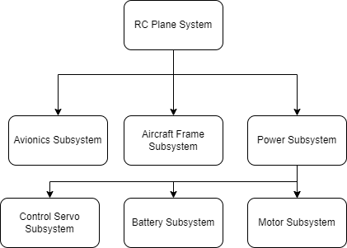

## Avionics Subsystem

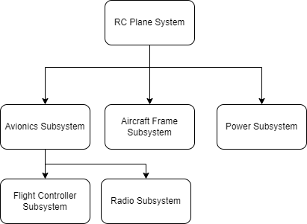

## Aircraft Frame Subsystem

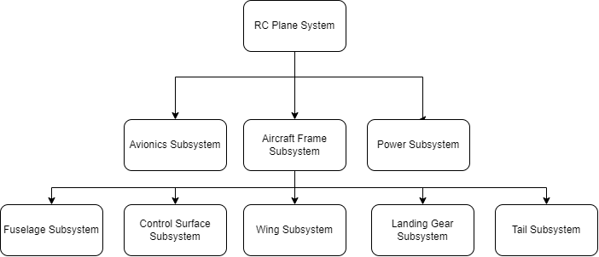

## SE Function 4: Concept of Operation

## SE Function 8: Technical Resource Budget Tracking

Expected Budgets we plan to track during the project:

### Mass Budget

So, I will want to keep an eye on at least the components I can get the exact weight of for now. I will do this in an excel document then transfer the finished over here.

### Cost Budget

Keeping an eye on just what I know of so far, obviously the motor and propellor will depend on further development as well as aircraft from cost in terms of printed material, rods, etc.



## SE Function 9: Risk Management

### Avionics Sys. Failure Modes



### Power Sys. Failure Modes



### Aircraft Sys. Failure Modes



## SE Function 10: Configuration Management and Documentation

All content except Fusion360 files will be stored in GitHub. Project management will also be done through GitHub to maintain traceability. If Fusion360 files are added, they can be uploaded daily with provided changes.

## SE Function 11: System Milestone Reviews and Reports

As I am the stakeholder, my reviews are kind of to myself? I can mark milestones using GitHub to identify major areas of the project such as finishing phases and scheduled testing dates.